**The Table of Nations: Genesis Chapters 10-11**

http://www.ldolphin.org/mcline.jpg

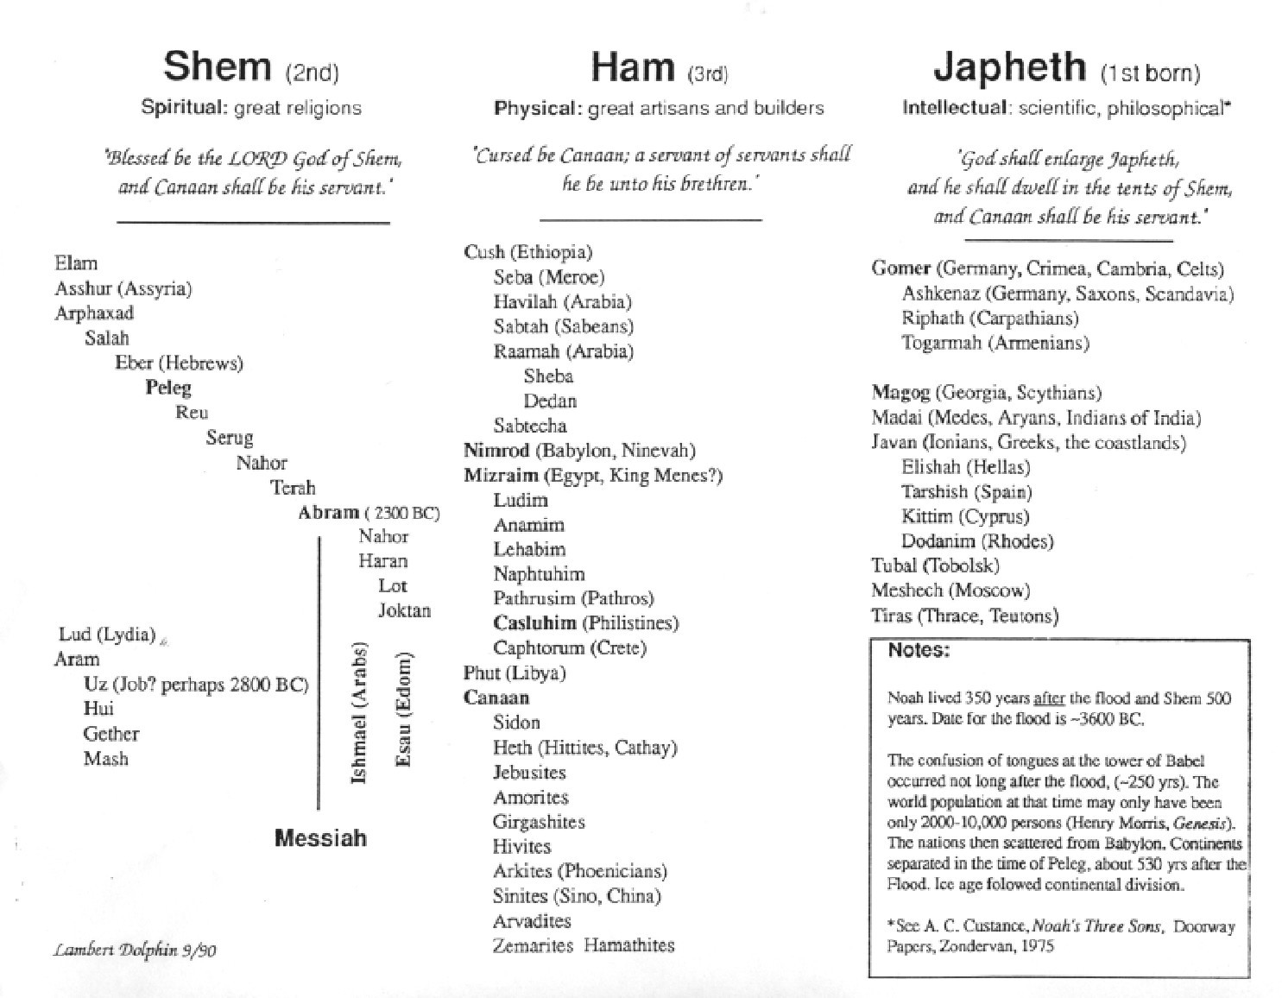

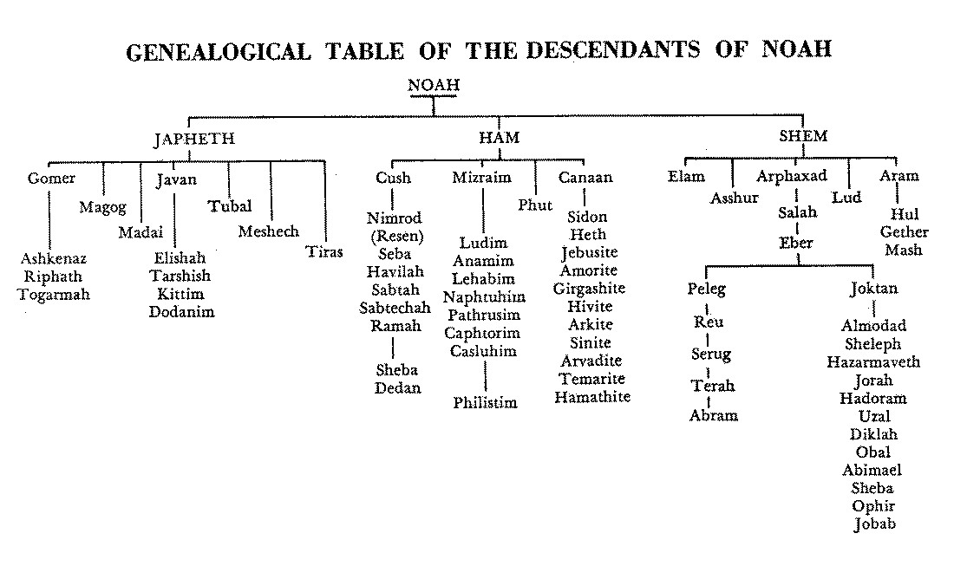

http://www.ldolphin.org/mcline.jpg

**Notes on Shem, Ham and Japheth by Ray C. Stedman**

...this answers a very widespread distortion of this passage that has been accepted for many, many years which says that the curse fell on the Negro people. The mark of it was a black skin, and therefore they are destined to be servants among mankind. But the Canaanites, as far as we know, were not black-skinned people. The curse was wholly fulfilled in Joshua's day when these descendants of Canaan, morally perverted through this evil strain which had survived the flood and now breaks out again in human history, were left alive by Israel. Thus there was loosed in society an evil element which has spread throughout the entire race since, and breaks out in sexual perversions from place to place. This is the biblical explanation for these things.

There is, however, a grain of truth in applying this passage to the Negro people. Most powerful lies gain their power from having at least a modicum of truth about them. It is true that the colored peoples of the earth are descendants of Ham, Hamitic people. They come in varying shades: the yellow of the Chinese, the brown of the Indians, the black of the Africans, and even including some that are white-skinned. Now we must turn to the prophetic words uttered by Noah about his sons as to the destiny of their descendants.

He also said [notice how he deliberately sets this apart from what he said about Canaan], "Blessed by the Lord my God he Shem; and let Canaan he his slave. God enlarge Japheth, and let him dwell in the tents of Shem; and let Canaan he his slave..."

Here we have the three families of mankind. The family of Ham is represented by Canaan, although not limited to his descendants. In certain of the old versions, in these two verses referring to Canaan, the account reads, "Ham, the father of Canaan," which is probably the more accurate rendering. Now this is a most important passage. We can hardly overrate its importance in understanding the world of our day...

Notice that Shem is given religious primacy among mankind. The Semitic people, the descendants of Shem, were responsible under God to meet the spiritual needs of mankind. That is their role in humanity. It is most striking, isn't it, that the three great religions of earth, which can properly be called religions, all come from the Semitic family: Judaism, Mohammedanism, and Christianity. There is much distortion of truth in these, granted, but the sense of mission by the Semitic families of earth is very evident. This family includes the Jews, the Arabs, certain ancient peoples, as well as other modern groups.

Japheth was promised enlargement. The Japhethic people are, in general, the peoples of India and Europe, the Indo-European stock, with which any demographer is familiar. It is largely from this family that we Americans come. It is most interesting that history has recorded their geographical enlargement. The entire Western hemisphere of our globe is settled by Japhethic peoples, and the Indians (Hindus) are of the same stock. But there is much to suggest in history that the enlargement that is promised here to Japheth is also intellectual. Historically, all the great philosophers are Japhethic. The Greeks, who began modern philosophy, are descendants of Japheth, as we will see in the very next chapter, also the Hindus. The Greeks and the Hindus are the two truly great philosophic races of earth. Some of you may say, "Well, what about Confucius; he was a Hamite?" But Confucius was not a philosopher; he was a teacher of practical ethics. Anyone who studies him will realize how true this is.

There is a very astute Christian scholar, whose writings are privately distributed, who has been a great help to me in various fields of Bible study. His name is Dr. Arthur Custance, from Toronto, Ontario, to whom I am greatly indebted for some of these concepts. He takes the phrase, "let him [Japheth] dwell in the tents of Shem" as predictive of the Cross, when the spiritual guidance of humanity passed from the Jews to the Gentiles, i.e., to the Japhethic family. To Shem was given the primacy of religious teaching, but there comes a time when Japheth enters that field ("dwells in the tents of Shem"), and philosophy (which is essentially Japhethic) was married to theology. This has been the case since the dispersion of the Jews around the world.

There is much more we will say on this as we go on into chapter 10, but let me speak briefly about Ham. Ham is given the role of a servant in relation to both of these other families of earth. But, notice carefully, not a servant in the sense of enslavement. That role was limited to the descendants of Canaan. "A slave of slaves," is the Hebrew way of emphasizing, of intensifying a statement. Canaan was to be that, but not the rest of the sons of Ham. However, they were to fulfill a servant relationship, not in the sense of enslavement, but as the practical technicians of humanity. If you study ancient history and technological achievements which were in many ways the equal of, or superior of, much that we have today, were founded and carried to a high technological proficiency by Hamitic people. This is the role in history given by God to the descendants of Ham. The Egyptians, the Babylonians, the Mayans, the Aztecs, all were Hamitic people. They were the great inventors of mankind. It may come as a shock to some, who boast in Aryan superiority and think of Americans as the most inventive people on the earth, to know that almost every basic invention can be traced to the Hamites, rather than to the Japhethites, which we represent. All that Japhethic people do is to develop the philosophy of science and apply technology, but the discovery of these are largely traceable to the Hamitic peoples of the earth.

Now, to bring this introduction of the subject to a conclusion, all of this is reflected most interestingly in the New Testament. We have for instance, the so-called Synoptic gospels (Matthew, Mark, and Luke), which are very similar to one another and quite different from the gospel of John. Yet Matthew, Mark, and Luke are not copies of one another but they represent differences of approach. It has often been pointed out that they are aimed at different types of people. The interesting thing is that when you inquire who these people are you find that they are Shem, Ham, and Japheth, in that order. Matthew is aimed at the Semitic people. It is the gospel for the Jews, above all others. Mark is clearly the gospel of the servant. This is stressed by Bible teachers whenever they teach Mark; his gospel is profoundly the presentation of the servant, the practical mind, the Hamitic mind. Luke is clearly aimed at the Greek, or the Japhethic mind.

It is also interesting that three groups are recorded in the New Testament as specifically coming to seek the Lord Jesus. They are: the shepherds, the Wise men, and the Greeks. Here you have again the order: Shem, Ham, and Japheth. The shepherds were Israelites, Semitic. Most Bible scholars feel that the Magi, the Wise men from the East, were really not from the East (that was a general term) but from Arabia, and represent the Hamitic peoples. The Greeks are clearly Japhethites. So there again, always in the same order, we have Shem, Ham, and Japheth.

Also, the gospel, was first preached in this order. In the book of Acts we are told that on the day of Pentecost Peter stood up and said, "Ye men of Israel," and addressed the gospel to them. Then in the next section we find Philip called to leave a revival in Samaria and go down to preach to a single individual in the desert, who is a Hamite, an Ethiopian, the treasurer of Ethiopia. Then, a little bit later on, Peter is sent to the Japhethites, preaching the gospel to Cornelius, a centurion of Rome.

Furthermore, all three of these groups are represented at the crucifixion. Each branch of mankind took part in the crucifixion. The moral responsibility for it fell upon the Jews. It is they who said, "His blood be upon us and. upon our children." The physical burden of bearing the cross fell upon a Hamite, Simon of Cyrene, a stranger in Jerusalem who was impressed into the task of bearing the cross for our Lord on the Via Dolorosa, Finally, as you know, executive responsibility for the crucifixion rested with the Romans, who gave the official order for the death of our Lord.

Now we shall see much more of this in chapter 10, but I think this is enough to show how accurately the Bible previews history, and how it deals realistically with these matters. There are often hidden in trace them, carry us into vast and exciting fields of discovery. we have looked at enough to confirm to us this fact: that the race, the whole race, is but the individual written large. There are three divisions of mankind, as there are three divisions in man, in you. To each of these divisions is given the responsibility for meeting one of the basic needs of man, spiritual, physical, and intellectual. In each one of us these same three divisions are found. We each have a capacity to worship; we each have a capacity to reason; and each has a capacity to create. These are the things that distinguish us from the animals. This is the image of God in man. Each of them needs to be held in perfect balance. The world is in a state of confusion, uncertainty and despair because the balance God intended has been left unfulfilled, so, in your individual life you are in a state of confusion, despair, frustration, weakness, or whatever it may be, because you have neglected to fulfill the three-fold capacities of your own nature. You can only do so as they are kept in perfect harmony, one with the other.

It is wrong to think of man as essentially spiritual. He is also intellectual and physical. It is wrong to think of him as being essentially physical, and to develop the athletic abilities to the neglect of the others; he is also spiritual and intellectual. The interesting thing is that in the Bible the intellectual is put last. If the order of scripture obtains for the individual as well as for the race, the order within us is also Shem, Ham, and Japheth. First the spiritual, then the physical, then the intellectual. In that order mankind finds its complete fulfillment. If we understand ourselves we will also understand the world around us. The glory of the gospel is that it addresses itself to mankind exactly on those terms. We find ourselves entering into fulfillment, into excitement, into a dramatic sense of being what we were intended to be, when we open our lives to God through Jesus Christ, making that our first priority; then developing the physical life, taking care of physical needs, physical demands; and through these two working together, developing the intellect to an understanding of ourselves..."

------------------------------------------

### Notes on the Table of Nations by Ray C. Stedman

Chapter 10 of Genesis is a record of how mankind fanned out over all the earth, like spokes in a wheel, radiating from a center which both science and Scripture place in the Middle East. The Middle East has been called, "the cradle of civilization," or "the cradle of mankind." We are now dealing with the days immediately following the Flood, when the sons of Noah became the heads of three major divisions or families of mankind. In this chapter we learn how they spread throughout the earth. We have already studied the prophetic utterance of Noah concerning the contribution his three sons and their descendants would make to humanity.

We saw that to Shem was given the religious primacy of mankind. The Semitic peoples are responsible, under God, to develop the spiritual life of mankind. It is not surprising, therefore, that from the Semitic peoples have come the three major religions of earth: Judaism, Mohammedanism, and Christianity. To Ham was given the art of technical proficiency. The Hamitic people are the technicians of mankind, showing an amazing adaptability to the world in which they live. To Japheth was given intellectual enlargement, and the widest geographical distribution of the three families. History has long since confirmed abundantly this distribution of mankind, exactly as the Bible says...This is the kind of chapter that requires careful and exhaustive study, but I shall merely attempt a quick survey, pausing where Moses, the author of Genesis, also pauses to make comment on certain names that appear in this section. These are important comments and we need to understand why Scripture suddenly turns the spotlight upon certain individuals.

The division begins with Japheth and his descendants,

**These are the generations of the sons of Noah, Shem, Ham and Japheth; sons were born to them after the flood.**

**The sons of Japheth: Gomer, Magog, Madai, Javan, Tubal, Meshech, and Tiras. The sons of Gomer: Ashkenaz, Riphath, and Togarmah. The sons of Javan: Elishah, Tarshish, Kittim, and Dodanim. From these the coastland peoples spread. These are the sons of Japheth in their lands, each with his own language, by their families, in their nations. {Gen 10:1-5 RSV}**

This division of the chapter, centering on Japheth, is the shortest, yet to us in many ways it is the most important, because it is to this family of mankind that most of us belong. We are Japhethites and we find this of intense interest, although the Scripture spends the least time with it.

Those who study races and peoples are known as ethnologists, and one of the tools of ethnology is to trace the persistence of names through history. Some of these place names and names of individuals persist for a long time through the course of human events, and form a kind of peg or nail upon which we can hang certain important movements in history and by which we can trace certain developments. We can do this with many of the names in this passage. Letters may be transposed, endings added, prefixes taken away or added, but there is a basic root which persists for years and even centuries of the time, and these give us a way of tracing the spread of the peoples of earth.

The family of Japheth is essentially what we call the Aryans. Hitler made much of the Aryan race, claiming that the Germans were pure Aryans and the rest were mongrels. Of course, the Jews were of a completely different family. He was right about that, for the Jews are Semitic (from Shem) while the Aryans are from Japheth. But where Hitler made his mistake (and where many people today make a mistake) is to fail to differentiate between differences which exist between people and a supposed superiority. Because people are different is no sign that they are inferior or superior. This is one of the basic things we need to understand in studying the peoples of the earth.

Early in the history of the world, the Japhethites, or Aryans, split into two groups. One group settled in India and the other group in Europe. Together they form what is known as the "Indo-European" family of nations. Any ethnographer is familiar with these divisions, but they are the same basic stock. The next time you visit India you should realize that you are visiting your cousins in the same basic family. The interesting thing is that both of these divisions, the Indian and the European, trace their ancestry back to Japheth. This is not from the Bible, but from history:

The Greeks say that their ancestor was a man named Japetos, and you can see in that the resemblance to Japheth. They regarded him as not only the father of their race, but the father of all humanity. The Indians, on the other hand, have an account of the flood similar in many respects to the Biblical account. The name of their hero is not Noah, but Satyaurata, and he had three sons. The name of the oldest was Iyapeti (you can see Japheth in that, very easily), and the other two were Sharma, and C'harma (Shem and Ham). The interesting thing about the Indian account is that C'harma was cursed by his father because he laughed at him when he got drunk, a certain echo of the story we have in Genesis.

You see from this how this chapter is embedded in history. The Word of God is dealing with realistic matters when it traces these divisions.

We learn here that Japheth had seven sons, but only two of them are traced for us in any detail: The first son was Gomer. From this word, Gomer, by a process of elision and transposition of letters, there came the word, Gaul, or Gallic. These are the people, interestingly enough, to whom the New Testament Epistle to the Galatians is written. The Galatians were Gauls. Most of us have a Gallic or Celtic (or Keltic) ancestry, and the Gauls and Celts (or Kelts) were descendants of Gomer. They migrated to the north and settled in Spain, France and in Britain. From these Gauls come most of the early families of Western Europe and, consequently, of the Americas as well.

The oldest son of Gomer was Ashkenaz. He and his descendants first settled around the Black Sea and then moved north into a land which is called Ascenia, and which later became known as the Islands of Scandia, which we now know as Scandinavia. You can trace a direct link between Ashkenaz and Scandinavia. Another of the sons of Gomer was Riphath. Although we do not know too much about Riphath, we do know that he located in Central Europe, and some scholars feel that the word, Europe, itself comes from this name, Riphath. Another son is Togarmah. This name is easily traced. He was the ancestor of the present-day Turks and Armenians, who also migrated northward into Southern Germany. Certain scholars have felt that the word, Germany, derives from the word, Togarmah. If you drop the first syllable you have the basic root of Germany.

Two others of the sons of Japheth were Madai and Javan. These are easily recognizable in history: The Madai became the Medes, of the famous Medes and Persian Empire. Javan is unquestionably the ancestor of the Greeks. His name, Javan, is still found in Greece in the form of Ionia. The Ionic Sea and Ionian Peninsula all derive from this word *Javan*. His sons were Elishah, from which we get the Greek word, Helles (the Greeks are still called *Hellenes*), and Tarshish, whom most scholars associate with Spain; Kittim, which is the Island of Cyprus; and Dodanim, who settled around the Black Sea, and still finds a modern parallel in the word, the Dardanelles. These can all be traced by the geographical titles and place names they left behind.

Next is the family of **Ham**, which is the family gifted with technical proficiency. Because of the great adaptability of these people to primitive conditions, the Hamites became the great pioneers of mankind. All the early civilizations were Hamitic: the Egyptians, the Babylonians, the Mayans, the Aztecs, the Sumerians. These were the people most able to adapt themselves to the conditions they found wherever they settled. We owe a great deal to the Hamitic nations. Later on, these lands were occupied by Japhethic nations, and at the present day the entire Western hemisphere is peopled by Japhethic rather than Hamitic nations, though it was once the other way around.

We shall take the family of Ham in two sections, briefly commenting on certain items:

**The sons of Ham: Cush, Egypt, Put, and Canaan. The sons of Cush: Seba, Havilah, Sabtah, Raamah, and Sabteca. The sons of Raamah: Sheba and Dedan. Cush became the father of Nimrod; he was the first on earth to be a mighty man. He was a mighty hunter before the LORD; therefore it is said, "Like Nimrod a mighty hunter before the Lord." The beginning of his kingdom was Babel, Erech, and Accad, all of them in the land of Shinar. From that land he went into Assyria, and built Nineveh, RehobothIr, Calah, and Resen between Nineveh and Calah; that is the great city. Egypt became the father of Ludim, Anamim, Lehabim, Naphtuhim, Pathrusim, Casluhim (whence came the Philistines), and Caphtorim. {Gen 10:6-14 RSV}**

The four sons of Ham are relatively easy to trace in history: Cush is associated with the peoples of Southern Arabia and Ethiopia. Ethiopians still trace their ancestry back to Cush. Egypt is self explanatory. Egypt (or *Mizraim* in Hebrew, an ancient name for Egypt) became the father of the Egyptian Empire, settling in the Nile Valley. Put is associated with Lydia, on the west of Egypt, in North Africa. Canaan centered largely in and around Palestine, though the Canaanites later became much more widespread, as this account tells us further on.

The account zooms in on an individual named Nimrod, who is called a great hunter. He is a rather mysterious figure, of great importance in ancient history. He is the founder, as we are told, of both Babylon and Nineveh, the two great cities of antiquity which ultimately became enemies of Israel. The prominent thing said about him here is that he was a mighty man, "a mighty hunter before the LORD." Now it was the work of kings in those ancient days to be hunters. This was a time when civilization was sparse and wild animals were a constant threat to the peoples. Kings, having nothing much else to do, organized hunting parties and acted as the protectors of their people by killing wild animals. Nimrod evidently gained a great reputation as such a hunter, but he was more than a hunter of wild animals. The Jewish Talmud helps us here, for it says that he was "a hunter of the souls of men." By the founding of Babylon and Nineveh we have a hint given of the nature of this man. We are told here that he was "the first mighty man on earth," i.e., after the Flood. That phrase, "mighty man," takes us back to Genesis 6 where, in that strange story of the invasion of the "sons of God" into the human race, there resulted a race of giants called Nephilim. We are told that, "these were the mighty men that were of old, the men of renown." This was evidently a demonic invasion of the race, with sexual overtones, which brought into being a race of giants that were morally degraded. These also appear later on in the Canaanite tribes. We have found this suggestive line of thought running through the Scriptural account up to this point. It now suggests that Nimrod was one of these "mighty men," and therefore introduced a perverted, degraded form of religion into the world. It began at Babylon, spread to Nineveh, and can be traced in history as it subsequently spread throughout the whole of the earth. Thus, in this man Nimrod, we have the seed of idolatry and false religion coming in again after the Flood.

If you drop the first consonant of Nimrod's name and take the others -- M, R, D -- you will have the basic root of the god of Babylon, whose name was Marduk, and whom most scholars identify with Nimrod. In the Babylonian religion, Nimrod (or Marduk) held a unique place. His wife was Semiramis. (Some of you who have been at Cairo have stayed at the Semiramis Hotel, which is named after her.) Marduk and Semiramis were the ancient god and goddess of Babylon. They had a son whom Semiramis claimed was virgin-born, and they founded the mother and child cult. This was the central character of the religion of ancient Babylon, the worship of a mother and child, supposedly virgin born. You can see in this a clever attempt on the part of Satan to anticipate the genuine virgin birth and thus to cast disrepute upon the story when the Lord Jesus would later be born into history. This has been the effect of it.

This ancient Babylonian cult of the mother and child spread to other parts of the earth. You will find it in the Egyptian religion as Isis and Osiris. In Greece it is Venue and Adonis and in Hindu it is Ushas and Vishnu. The same cult prevails in various other localities. It appears in the Old Testament in Jeremiah, where the Israelites are warned against offering sacrifices to "the Queen of Heaven." This Queen of Heaven is Semiramis, the wife of Nimrod, the original mother of the mother and child cult. The cult has also crept into Christianity and forms the basis for the Mariolatry that has prevailed in Roman Catholic Church, where the Mother and Child are worshiped as joint redeemers.

If you would like to read more on this, there is a book by Alexander Hislop, a very authoritative writer in this field, called *The Two Babylons.* I am sure you will find it of great interest if you desire to pursue this further.

This idolatrous religion culminates at last in the Bible in the book of Revelation. You remember the "great harlot" that appears there whose name is "Mystery Babylon the Great," the originator of all the harlotries and false religions of earth. The essence of Babylonianism, as we understand from Scripture, is the attempt to gain earthly honor by means of religious authority. That is Babylonianism, and it has pervaded Christian churches, Hindu temples, Buddhist shrines, and Mohammedan mosques. Everywhere it is the element that marks falseness in religion, this attempt to gain earthly power and prestige by means of religious authority. That is Babylonianism. That is what Nimrod began and what God will ultimately destroy, as we read in the book of Revelation.

The land of Shinar, mentioned here, is also the land of Shunar or Shumar, from which we get the word, Sumeria, and the Sumerian civilization, with which scholars are familiar. The city of Resen was founded by people who later migrated into the north of Italy and began the great Etruscan Empire, which again is familiar to any who study ancient history. We also have here the countries that came from Egypt and are associated with it here, all of which are countries of North Africa.

One further note on this section: Note that the Philistines, which appear frequently elsewhere in the Old Testament, are linked with the Egyptians. This is significant, for Egypt in the Bible is always a picture of the world; the Philistines are a picture of the flesh in its religious aspect, religious flesh or Pharisaism, if you like. These are forever typified by these two nations. The second section of the sons of Ham centers on the descendants of Canaan,

**Canaan became the father of Sidon his first-born, and Heth, and the Jebusites, the Amorites, the Girgashites, the Hivites, the Arkites, the Sinites, the Arvadites, the Zemarites, and the Hamathites. Afterward the families of the Canaanites spread abroad. And the territory of the Canaanites extended from Sidon, Gomorrah, Admah, and Zeboiim, as far as Lasha. These are the cons of Ham, by their families, their languages, their lands, and their nations. {Gen 10:15-20 RSV}**

In a previous message we saw that these constituted the Canaanite tribes which occupied the land of Palestine at the time of Abraham. They were a morally degraded people, and were that as a result of demonic invasion. That does not mean that every individual was demonically possessed, but there was considerable experience of this among these people. We must note certain individuals in this listing, but not all:

Sidon is mentioned as the first-born of Canaan. He founded the city by the same name, located near Tyre, on the coast of Phoenicia. Since there is no mention of Tyre here we can see how early this account is. Heth is the father of the Hittite nation. The Hittites were once regarded by archaeologists as a biblical blunder. Archaeologists said the Bible was absolutely wrong when it mentioned the Hittites, for there was no such people. But since that time, Hittite relics have been discovered in abundance, and scholars are now well aware of the great civilization that flourished under the Hittites. The Hebrew form of this word, Hittite, is *Khettai* and from this comes the word *Cathay*, which many of you will recognize as an ancient name for China. Certain of the Hittites migrated eastward and settled in China. Also, another name in this list, the Sinites, is linked with China. It derives from a presumed son of Canaan whose name was Sin. The Sinites migrated eastward until they came into Western China, where they founded the ancient Empire of China and gave their name to the land. There is a direct connection between the word *China* and the word *Sinim*, the biblical name for China. (I remember reading as a boy of the Sino-Japanese War, showing how the ancient name still persists.) They pushed eastward and toward the north over the land bridge into Alaska. The Sinites are the people who settled the Americas in prehistoric days and became the ancestors of the Eskimos and Indians who, to this very day, betray their Mongoloid ancestry.

Now the third family that is traced here is **Shem**:

**To Shem also, the father of all the children of Eber, the elder bother of Japheth, children were born. The sons of Shem: Elam Asshur, Arpachshad, Lud, and Aram. The sons of Aram: Uz, Hul, Gether, and Mash. Arpachshad became the father of Shelah; and Shelah became the father of Eber. To Eber was born two sons: the name of the one was Peleg, for in his days the earth was divided, and his brother's name was Joktan. Joktan became the father of Almodad, Sheleph, Hazarmaveth, Jerah, Hadoram, Uzal, Diklah, Obal, Abimael, Sheba, Ophir, Havilah, and Jobah; all these were the sons of Joktan. The territory in which they lived extended from Mesha in the direction of Sephar to the hill country of the east. These are the sons of Shem, by their families, their languages, their lands, and their nations.**

**These are the families of the sons of Noah, according to their genealogies, in their nations; and from these the nations spread abroad on the earth after the flood. {Gen 10:21-32 RSV}**

The noteworthy thing said here is that:

Shem was the father of the children of Eber. Actually, Eber was a great-grandson of Shem, but from Eber comes the word *Hebrew*. Abraham, who was really the founder of the Hebrew nation, was six generations beyond Eber. Yet Eber is of such note that Abraham is identified as an Eberite, or Hebrew.

Elam, the next son of Shem, is associated with Southern Mesopotamia. Archaeologists have now found that the earliest inhabitants of this area were Semites, not Hamites, as they once thought. Asshur is the one who gave his name to Assyria. The genealogy closes with Eber's two sons, Peleg and Joktan.

The tribes listed as from Joktan are all associated with Arabia. The boundaries of Mesha and Sephar given here are both within the Arabian Peninsula. Our main interest, however, centers on Peleg and this cryptic comment made about him, "in his days the earth was divided." What do you think that means?  *Peleg* in Hebrew, means "Division," but in Greek it means "Sea." We get our present English word *archipelago* from this: *archi-pelagos*, the first sea. The Greeks called the Aegean Sea "The Archipelago," the first sea, drawing the name from this man, Peleg.

There is some evidence to link this with the scientific theory of continental drift; the idea that once the continents were bound together in one great land mass, but sometime in the past they separated and began to drift apart until the Americas came to their present location, Australia slid down into the south, Antarctica still further south, and the continents assumed the present distribution of land mass on the earth. Some have suggested that this may have occurred as late as the days of Peleg, immediately following the Flood. Perhaps the great rift valleys of Africa and Asia had not yet formed, and, in Peleg's day, these drew apart so that the seas broke into this inner world and formed the Red Sea, the Mediterranean Sea, and the Dead Sea. This would be the formation of the first sea, from which we get the word *archipelago*.

There are many geologists, of course, who would raise questions about this, for they would say this is far too late in history for anything like that to have occurred. The account here is much too brief for us to be dogmatic about this, but it is very suggestive.

If this were the case, it may well have been that the American continent was still in view of Europe and Asia in those days, and that as it moved westward gradually disappeared from the horizon. This gave rise to the many myths and stories about a lost continent called Atlantis which disappeared beneath the Atlantic. There are many interesting threads here that we would love to follow.

Now we must come to the explanation of the title I have chosen for this sermon, *God's Funnel*.  A funnel is an instrument or device for narrowing a flow of liquid or powder from a wide expanse to a narrow one. That is what God is doing here in Genesis 10. Shem is put last of the sons of Noah because God is narrowing the flow of sacred history down to the Semitic races. Shem is the neck of the funnel. God is restricting the stream of humanity that he will deal with personally and directly down to one family group, the family of Shem. In Chapter 11, Verse 10 on to the end of the chapter, he takes this up again and narrows it still further to one man, Abraham. From there it begins to broaden out again to take in Abraham and all his descendants, both physical and spiritual. The rest of the Bible is all about the children of Abraham, physically and spiritually. Here we have then one of the most important links in understanding the Bible.

Why does God do this? He has been accused of showing favoritism in picking the people of Israel for his link with humanity. But it is not that. God is no respecter of persons, as we are told. He does this because it is necessary in view of the limitations of our minds, not of his. No one man can grasp the whole widespread, varied, world of mankind. We cannot do so even today. At election time we take polls to determine what people are thinking, because we cannot grasp or assimilate in any way what the entire mass of a people are thinking. We must take polls, samples. God is doing this with Israel. Israel becomes the sample nation, the sample people. Through the rest of the Bible, whatever is true of Israel is true of everyone; their story is our story -- your story and my story. Their stubborn rebellion is the same rebellion that we display, and their spiritual blessing under God is the same kind that we can expect if we open ourselves to respond to the grace of God. One fact comes drumming through all this otherwise dry genealogy: that is that God is seeking somehow to break through into our hearts and wills. He presses upon us in great historic sweeps and in the minor incidents that happen to each of us.

The great question we must raise in a service like this is:  Are you listening? Are you getting the message God wants you to get?

He writes it large upon the landscape of history, and also he writes it small in the incidents of your daily life. But in every case it is the same truth pressing through to us. God is essential to us. We cannot live without God. You cannot fulfill yourself, you cannot find yourself without him. He loves you, is seeking you, wants you, and is drawing you to himself. Forever this finds its confirmation in all of life around us. --from Ray C. Stedman, [The Beginnings.](http://www.ldolphin.org/the_beginnings.html)